1.0 Introduction

This document is created to assist in the software development testing plan for creating a Movie Database for Acme Entertainment Pty Ltd.

* 1. Roles

|  |  |  |
| --- | --- | --- |
| **SPRINT ONE** | **NAME** | **JOB TITLE** |
| Brandon Price | Software Tester |
| Luke Gough | Programmer |
| Kyer Potts | Scrum Master |
| **SPRINT TWO** |  |  |
|  |  |
|  |  |

* 1. Arconyms

List any terms used in the testing plane

| **ACRONYM** | **DEFINITION** |
| --- | --- |
| Acme | Acme Entertainment Pty Ltd |
|  |  |

1.3 Testing Tools

| **Tools** | **DESCRIPTION** |
| --- | --- |
| Windows 10 Operating System Device | A desktop computer that runs Windows 10 operating system. |
| Android Operating System Device | A mobile phone that runs Android operating system. |

1.4 Scope

In Scope

The movie database must have four available search fields which is Title, Genre, Ratings, and Year of movie. All fields must be clearly labelled to know which field you are searching on.

One or more fields must be searched at a time to request data in the movie database. The more fields filled to search, the more specific the data results will be. So searching for data matching the four fields will have fewer results, than data that only must match one field result.

When the database display data according to the search result. It must always display eleven columns of different type of data of a specific movie. The eleven types of data for the specific movie is ID, Title, Studio, Status, Sound, Versions, Rating, Year, Genre and Aspect. However if there are no search results found, then data will not show up.

There also needs to be a bar graph, which is accessed through the main page (Index page) that shows the most searched for movies in the database.

The size of the Movie database page must scale depending on how big or small the page is, so that it is always the right size when in use by the user. This test must be done on three devices.  
  
Devices that can rotate its screen, must be able to keep a professional format and preserve all the data that was on the screen before the device rotated its screen.

Website must work on google chrome browser.

2.0 Test Cases

2.1 Windows 10

This is about testing Movie Database user interface stability, so all information fits on the page, no matter how big or small the Movie Database interface is.

For the first testing the Movie Database user interface will be accessed through a windows 10 operating system, through a Google Chrome browser.

The smallest size scalability. Working as intended. It compacts all information in the size scale it is at neatly. Test done on windows 10 operating system, with google chrome browser.

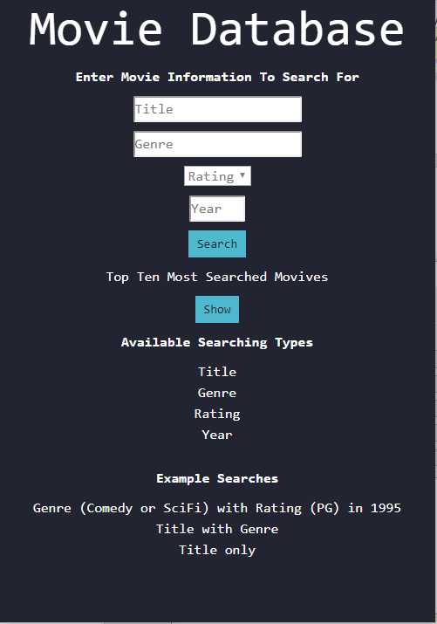

The second smallest layout. Working as intended. It compacts all information in the size scale it is at neatly. Test done on windows 10 operating system, with google chrome browser.

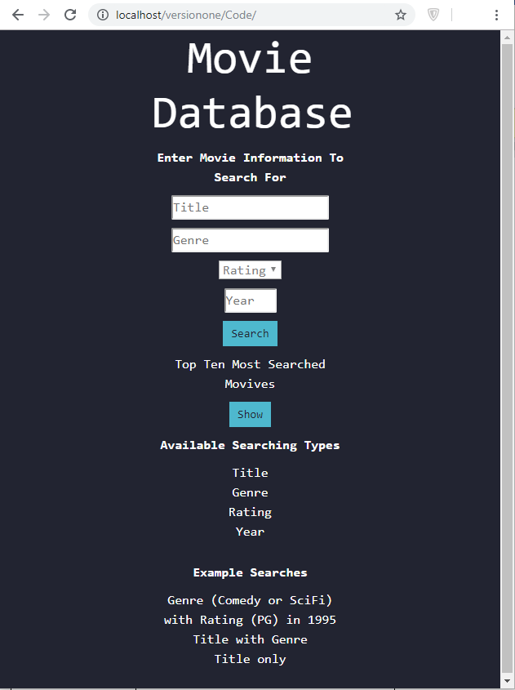

The second biggest layout. Working as intended. It uses more space in the page, in a neat manner.

Test done on windows 10 operating system, with google chrome browser.

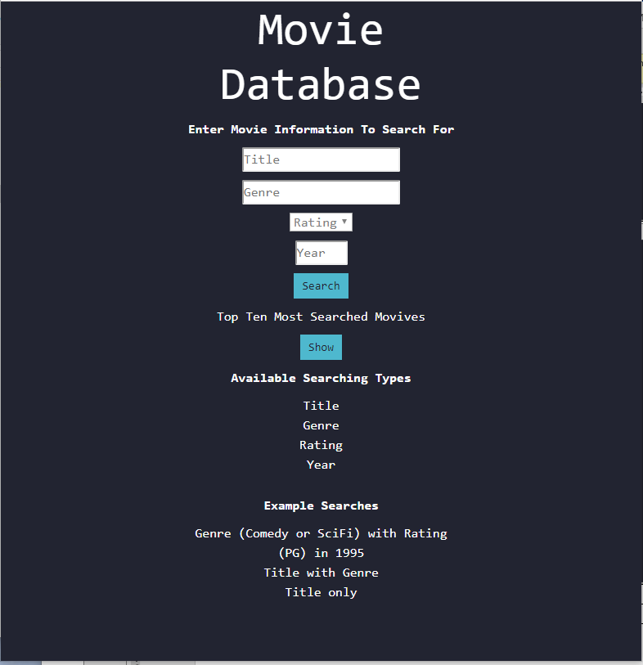

The biggest layout. Working as intended. It is now at its biggest scalability size. As you can see it looks neat and tidy. Test done on windows 10 operating system, with google chrome browser.

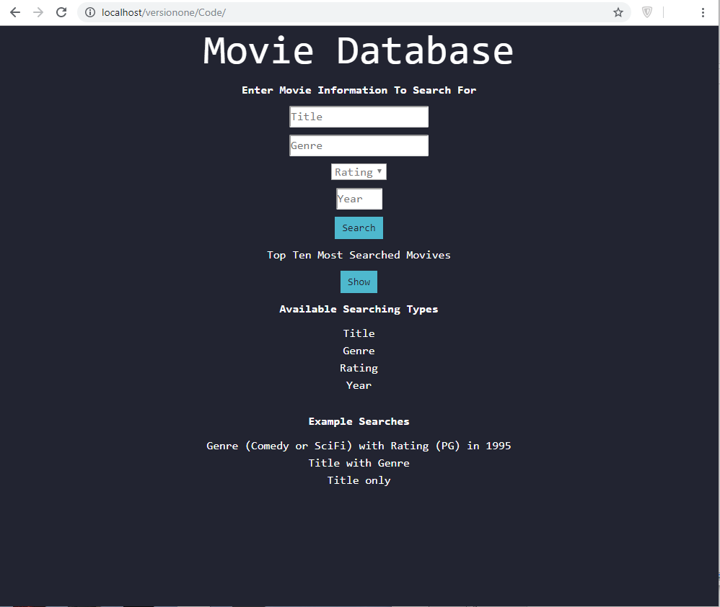

2.2 Android

Logging onto the Movie Database via accessing it through an android device on Google Chrome. Went successfully. The layout was perfect for the device. Filled in search information with user interface friendly input.

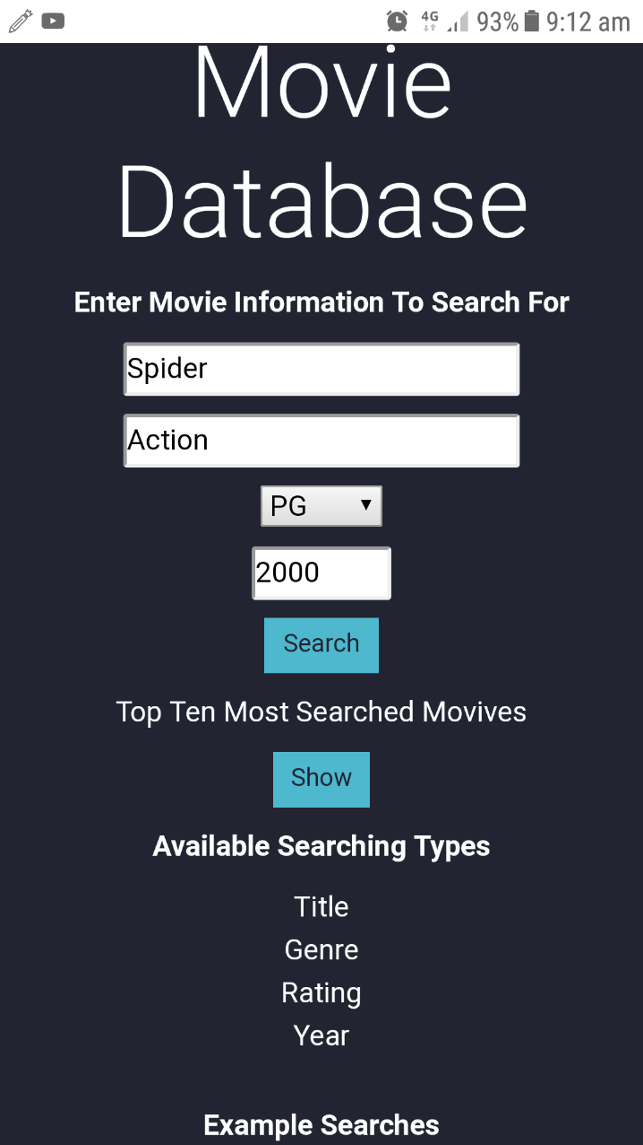

Example of mobile capabilities when entering input. Mobile version has a scroll option to input data. It is big enough to select rating/ratings easily.

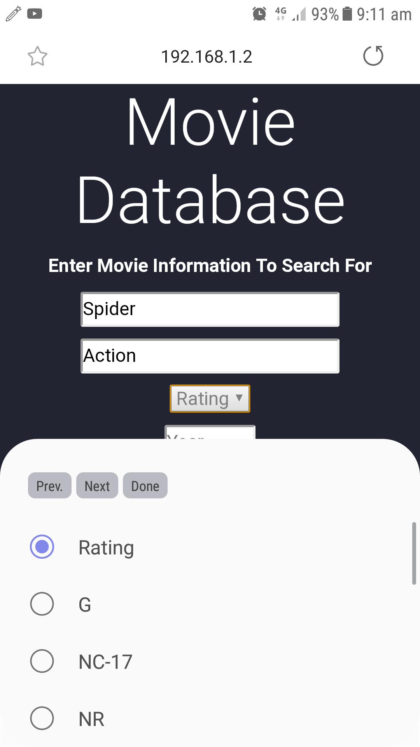

Changing the layout page to horizontal keeps all the information and also maintains user friendly interface.

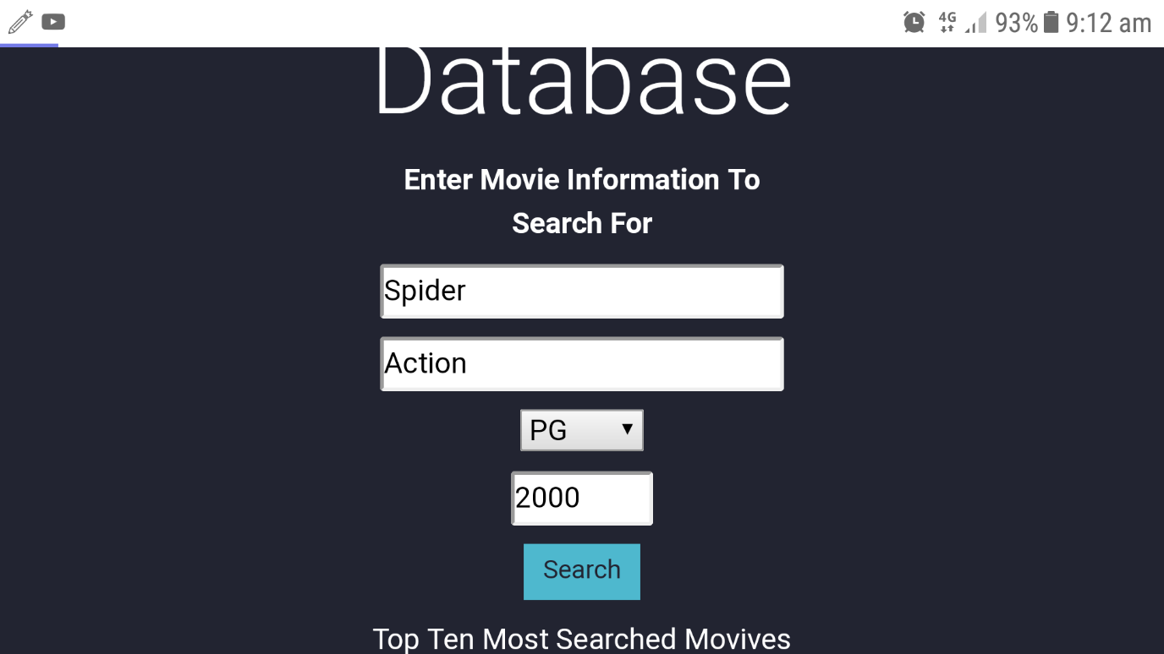

2.3 Testing Input And Output

Searching specific titles of movies. Works as intended. Displaying all results according to Title.

Test done on windows 10 operating system, with google chrome browser.

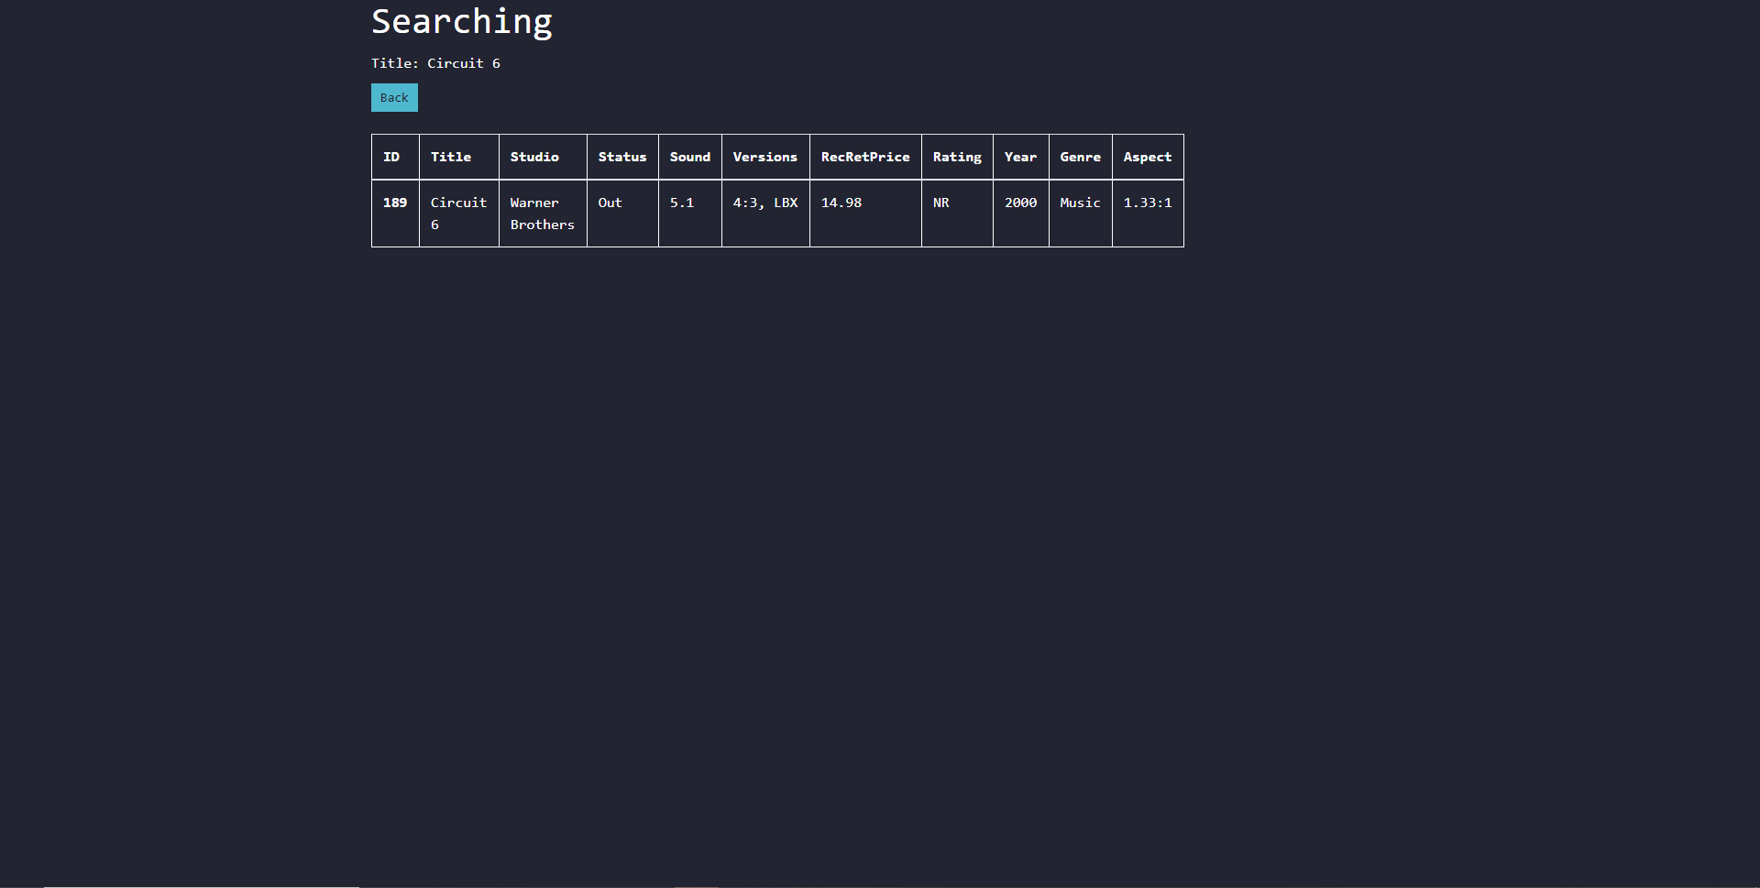

Searching specific Genres of movies. Works as intended. Displaying all results according to Genre.

Test done on windows 10 operating system, with google chrome browser.

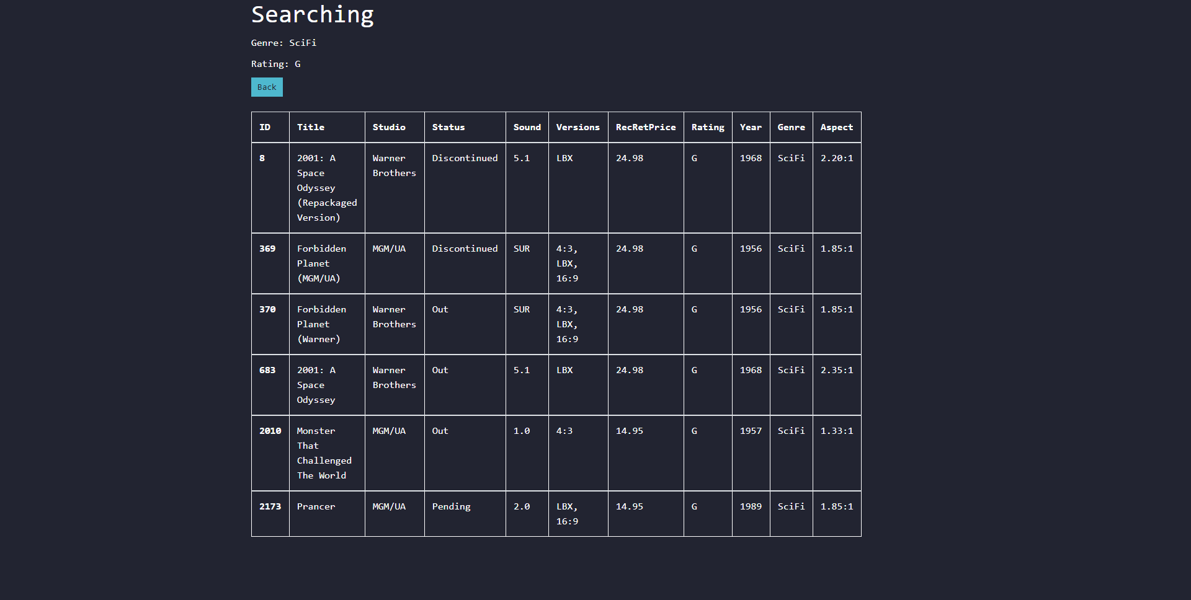

Searching specific ratings of movies. Works as intended. Displaying all results according to Ratings.

Test done on windows 10 operating system, with google chrome browser.

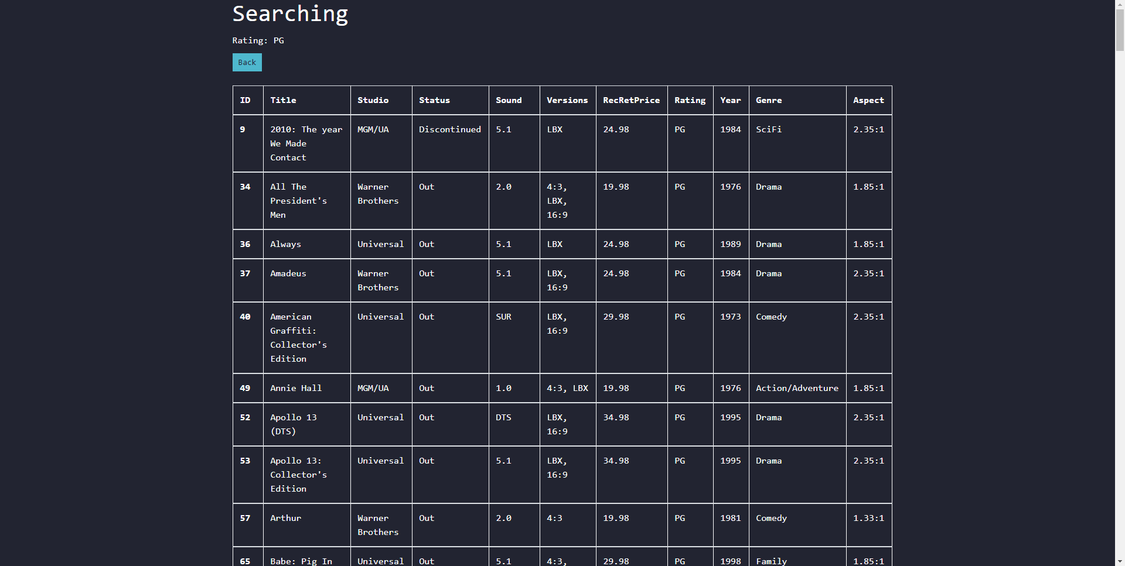

Searching specific years of movies. Works as intended. Displaying all results according to Year.

Test done on windows 10 operating system, with google chrome browser.

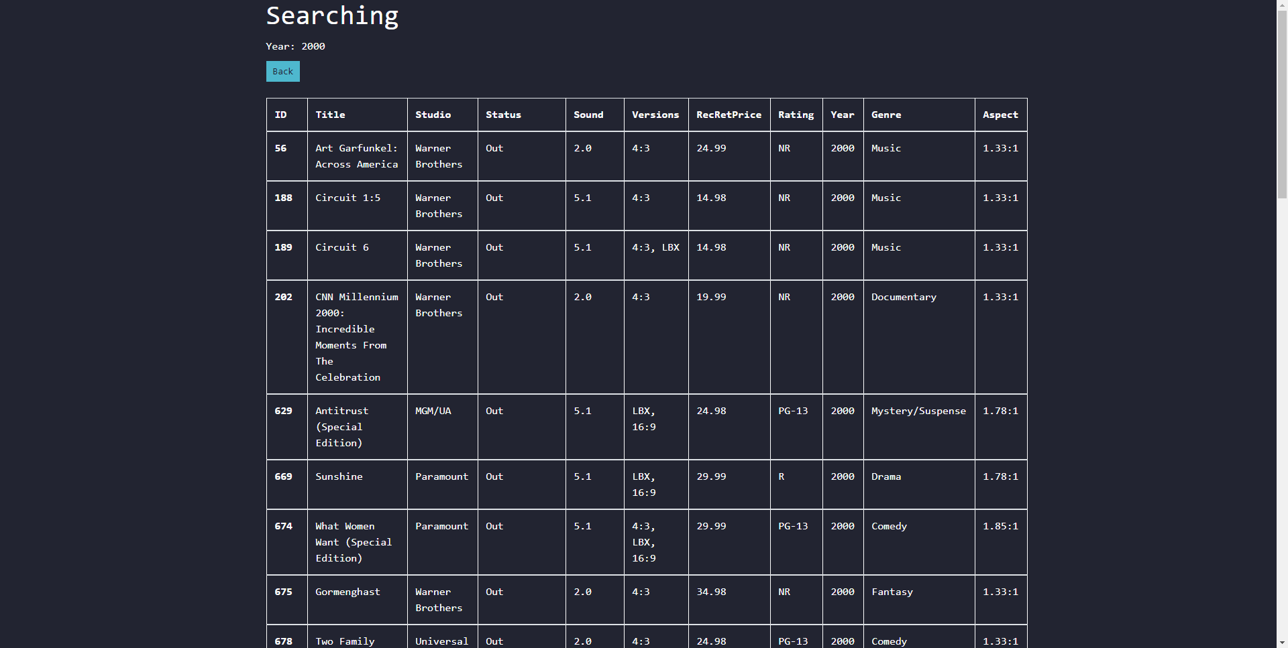

Clicking the back button takes your back to the home page. Working as intended.

Test done on windows 10 operating system, with google chrome browser.

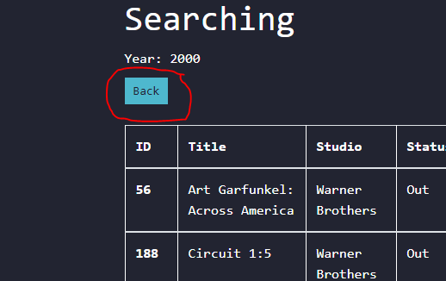

Clicking the Show button takes yo to a graph displaying the most searched results. Working as intended.

Test done on windows 10 operating system, with google chrome browser.

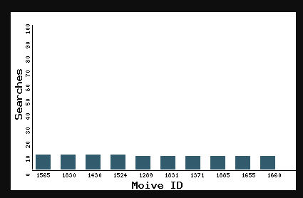

3.0 Validation

Everything tested so far has been made at a satisfactory standard, from testing the Movies Database on a Windows 10 Operating system with different sized screens, to testing the Movies Database on Android operating system with horizontal and vertical layout. Everything from the test study has worked out well.

All search terms to lookup movies on the database worked well as well. The database provides example search terms to understand how to search for movies. This is a flawless movie searching feature.

This product is ready to be reviewed by our client.